Accuracy Assessment of DEMGeneration Using HighResolution Stereo-Optical Satellite Imagery

MAHMOUD S. MAHMOUDª, ELHADI K. MUSTAFA^{b}, AMR H.AHMED ALIª, HOSSAM H. EL SEMARYª

ªBenha University, Faculty of Engineering-Shoubra, Surveying Engineering Department
^{b}Khartoum University, Faculty of Engineering, Surveying Engineering Department

Abstract
Digital Elevation Model (DEM) generation represents a continuous area of research, where there was a great demand for it in day to day applications. These applications move from electromagnetic propagation for telecommunication to more demanding simulations for acoustic, urban planning, virtual and augmented reality. Year after year radiometric quality and geometric accuracy of new high resolution satellites keep on improving so much where satellite imagery become a real potential solution for the production of such digital elevation models. This paper evaluates the accuracy of High Resolution Stereo-Optical Satellite Imagery (HRSI) for DEM production using rational function model (RFM) in Leica Photogrammetry Suite (LPS) environment. A well distributed set of ground points was determined and then surveyed using GPS surveying. These points were then divided into two sets: one will act as control set; while the other will be the check points set in order to evaluate the accuracy of the extracted digital elevation model. These points allow for qualitative and quantitative evaluation process. Several experiments have been performed to evaluate the resulted DEM. The resulted RMSe values of the experiments using 3 control points showed a horizontal absolute accuracy of 0.61m in East direction and 0.68m in north direction. Meanwhile, the vertical absolute accuracy reaches 1.05m. However, the best accuracy achieved using 10 control points to be 0.58min east direction and 0.67m in north direction for the horizontal absolute accuracy and 0.81mfor the vertical absolute accuracy.

Keywords: Stereo-Optical Satellite Imagery, Orthorectification, Digital Elevation Model, Horizontal Accuracy, Vertical Accuracy.

- Introduction

Topography is the base for many earth’s surface processes and thus finds applications in many fields such as hydrology, security, military, agriculture, climatology, communication, mining works, roads route (selection, design and execution) and other disciplines. Topographic mapping plays a tremendous role in local, national and international basis. Due to this fact, topographic mapping received good attention all over the world. The importance of topographic mapping as a national project is therefore growing rapidly. Also, the coin of geographic information system software, topographic maps and digital elevation models became the essential component of national geospatial data infrastructure. In developed countries, revised and up-to-date maps are continuously produced using current elevation data captured by remote sensing sensors. In developing countries, governmental Mapping Corporation and private mapping firms are lagging far away to produce fresh topographic maps or even to revise the existing ones at regular time intervals. This dim status is due to the fact of shortage, inadequate technical capacities in the area of geo-information and lack of knowledge about the importance and role of topographic maps and digital elevation models (DEMs) in local and national development. Taking Sudan as an example, only 200 topographic map (1:100,000) sheets out of 920 for the full coverage have been produced, covering only selected areas [1]. In addition, and up to now, no endeavors have been made by any Sudanese mapping corporation or firm to generate digital elevation models. Unfortunately, the process of extracting topographical information from existing topographical maps and integrating them in a new digital topographical map is usually a lengthy and time consuming process due to differences in map units and contour intervals[2].Currently, there are many satellites that offer stereo satellite imagery, such asCarto-sat1, CHRIS/PROBA, EROS-A, IRS, IKONOS, MOMS-02, and SPOT.

The studies of the application of IKONOS and SPOT5 imagery for mapping were already published. They showed that high-resolution satellite imagery was effective for mapping [3]. The 3D accuracy and bias compensation of IKONOS imagery were already studied [4]. Substantial research work has been conducted using stereo satellite imagery to map the Earth’s surface. Different procedures are used to extract the information, such as digital elevation models (DEMs) and orthoimages using imagery from SPOT satellites [5]. Nevertheless, the highest scale of mapping that can be achieved is 1:50,000 due to the coarse spatial resolution (20m) of the SPOT satellite image. Currently, the existence of the high spatial resolutions of less than a meter could serve numerous applications such as Earth monitoring, environmental modeling, geometric measurement and creation of the digital elevation models.

The main objective of this study is to analyze and evaluate the DEM generated from High Resolution Stereo-Optical Satellite Imagery. In this regard, the absolute differences between the generated DEM and User-defined 3D coordinates, based on GPS observation, were determined.

- Digital elevation model

DEM consists of a pattern of data points of known horizontal coordinates (X, Y) and height (Z) representing the terrain surface.DEM can be created from different pattern of data points depending on the collection procedures and used techniques. Data for DEM can be created by [6]:

- Digitizing the contour maps.
- Direct field observation by land surveying especially by the GPS or Total Station.
- Analytical or digital photograrnrnetric procedures.

The recent available technology to produce DEM automatically without assistance of ground control points is:(i) the inventory systems that integrate high accuracy inertial measurement unit (IMU) with a global positioning system (GPS) and a computer on board mapping aircraft; (ii) The Light Detection and Ranging System (LiDAR).Unfortunately, these methods are either time consuming (each sampling point has to be measured individually) and/or require experts, and a set of detailed control points. As an alternative, DEM could be produced with small scales using satellite base imaging such as SPOT and IKONOS [7].DEM creation implies the sequence of six processing steps. This routine is used for the creation of a DEM based on stereo images. These Steps are summarized as [8]:

- Acquisition and pre-processing of remotely sensed data (images and metadata) to determine an approximate value for each parameter of 3D physical model.
- Collection of ground control points (GCPs).
- Computation of the 3D stereo model
- Feature based image matching for automatic tie point selection.
- Computation of X, Y and Z cartographic coordinates from determined corresponding image coordinates
- Creation of regular grid through an interpolation process.

The root-mean-square error (RMSe) is used as a measure of how closely a data set matches the actual world DEM, which is considered to be the reference model [9]. In the case of DEMs acquired by means of space images, the accuracy is mostly depending upon the image resolution (ground sample distance), base-to-height ratio and image contrast (radiometric quality). A difference between a relative and an absolute accuracy can be noticed when systematic image errors have not be considered and the orientation quality is limited [10]. The vertical accuracy (the accuracy of a height) depends upon the accuracy of the x-parallax (Spx) and the base to-height ratio, B/H, of the imaging configuration [11]. It can be determined as follow:

$SZ=Scale*\frac{H}{B}*Spx$ (1)
$SZ=PixelSize*a*\frac{H}{B}$ (2)

Equations (1) and (2) are used for computing the standard deviation of height, SZ. The value of the parameter"a"which is a multiplication factor is usually below one pixel and the accuracy of the x-parallax (Spx) is depending upon the contrast and is also usually below one pixel.

- the stereo hrsi concept

Stereo products consist of two satellite images of the same location on Earth, taken from two different perspectives during one orbital pass. The pair of images is collected in-track, or on the same ground path just moments apart to maintain the tonal consistency between each image, enabling better interpretability. In our case, IKONOS stereo pair contains an image collected at a low elevation angle (above 60 degrees) as well as an image collected at a higher elevation angle (above 72 degrees) with 30°-45° convergence (0.54 to 0.83 base-to-height ratio).
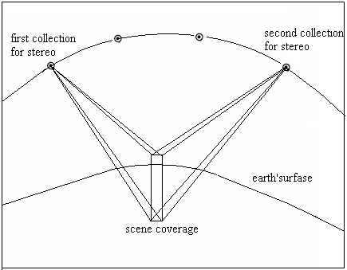
Figure (1): Stereo IKONOS Satellite Image data collection.

Reference Stereo products have a horizontal accuracy of 25 meters CE90 (Circular Error 90%) and a vertical accuracy of 22 meters LE90 (Linear Error of 90%) without any Ground Control Points (GCPs). When reliable GPS derived GCP is available the horizontal and vertical Geospatial accuracies increase to <2.5m horizontal and <1.5m vertical [12].

- Mathematical Model for HRSI

Sensor models are of particular importance to stereo reconstruction, image ortho-rectification and DEM generation, where they are essential to establish the functional relationship between the image space and the object space. Sensor models are typically classified into two categories: physical and generalized models. Recently, generalized models has gained considerable interest due to the requirement of real time processing and that the photogrammetric processing can be kept unchanged when deal with different sensors data as these generalized sensor models are independent. Therefore, the generalized sensor models are more common to be used in mapping community [13].

For IKONOS stereo images, the sensor physical parameters are derived from the satellite ephemeris and attitude data without using ground control points. The satellite ephemeris data are determined using on-board GPS receivers and sophisticated ground processing of the GPS data. The satellite altitude is determined by optimally combining star tracker data with measurements taken by the on-board gyros. Since the IKONOS satellite imagery vendor, Space Imaging Company, has not released the satellite ephemeris data, no physical mathematical model can be established. Consequently, some generalized generic mathematical models are needed to substitute the physical models for IKONOS Imagery restitution [14].However, the most common applied mathematical model is the rational function model (RFM) [15].

The Rational Function Model (RFM) is a generalized model that is widely used. During the few past years, RFM has come into widespread use within the intelligence community. This imaging geometry model uses ratios of two 3D order polynomial functions to compute the image coordinates [16]. The IKONOS satellite image company, Space Imaging, calculates the rational polynomial coefficients (RPCs) for each image and distributes these data with the images. Since rational polynomial considers heights into geometric correction, it is more adequate than 2D polynomials. It can be considered as the best choice when there is no information about the image and then a rigorous modeling cannot be used (as in the case of IKONOS satellite imageries).The validation of (RFM) model has been tested in several researches with aerial photography data and satellite imageries [13]. The test results show that both the rational function model and the polynomial model can reach reasonably good accuracy. Because the fitting accuracy of the cases with four-degree RFM is almost the same with those with six-degree RFM, high order forms are often not necessary. The iterative solution method to RFM provides a better accuracy than the direct solution method, but the direct solution method is usually adequate when enough control points are available.

The RFM expresses each of the x and y image coordinates as a ratio of two polynomial functions. It can be represented as follows:

$x=\frac{P1\left(X,Y,Z\right)}{P2\left(X,Y,Z\right)}=\frac{\sum_{i=0}^{m1}{\sum_{j=0}^{m2}{\sum_{k=0}^{m3}{a_{ijk}X^{i}Y^{i}Z^{i}}}}}{\sum_{i=0}^{n1}{\sum_{j=0}^{n2}{\sum_{k=0}^{n3}{b_{ijk}X^{i}Y^{i}Z^{i}}}}}$ (3)

$y=\frac{P1\left(X,Y,Z\right)}{P2\left(X,Y,Z\right)}=\frac{\sum_{i=0}^{m1}{\sum_{j=0}^{m2}{\sum_{k=0}^{m3}{c_{ijk}X^{i}Y^{i}Z^{i}}}}}{\sum_{i=0}^{n1}{\sum_{j=0}^{n2}{\sum_{k=0}^{n3}{d_{ijk}X^{i}Y^{i}Z^{i}}}}}$ (4)
Where,
x,y | Image coordinates
X,Y,Z | Ground coordinates
a_{ijk}, b_{ijk},c_{ijk},d_{ijk} | Polynomial coefficients (total 80)
m₁,m₂,m₃,n₁,n₂,n₃ | 0-3 , wherei+j+k ≤ 3

The polynomial coefficients are called rational function coefficients (RFCs). In general, distortions caused by optical projection can be represented by ratios of first-order terms, while corrections such as earth curvature, atmospheric refraction, and lens distortion etc., can be well approximated by second-order terms. Some other unknown distortions with high order components can be modeled using a RFM with third-order terms. A detailed description of how the RFM works can be found in [13].

The RPCs are calculated by Space Imaging from the satellite ephemeris and attitude data instead of releasing the ephemeris data themselves. Therefore, the RFM model is implemented by most of the commercial software packages in order to use the supplied RPCs. This software modules deal with IKONOS satellite images by reading the RPC files and applying the RFM model to orient the IKONOS imageries [17].

- Study Area and Stereo IKONOS Images Acquisition

The test area (Wadi seidna) is located at the north of Khartoum in Sudan bout 16km north of Omdurman city and geographically, it lies between upper left corner coordinates of (444535.977, 1747921.762) and lower right corner coordinates of (449800.083, 1742045.500). The elevation range of this area is about 60 m. The study area is about 31 Square Kilometers. Figures (2) and (3) show the general location of the study area.
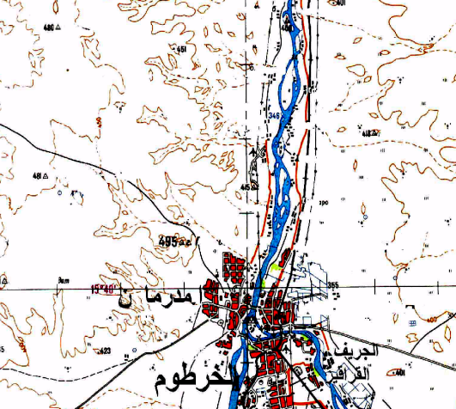 | 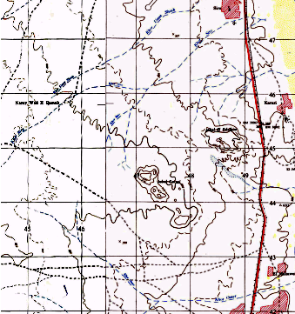
Figure (2): General location of the study area.

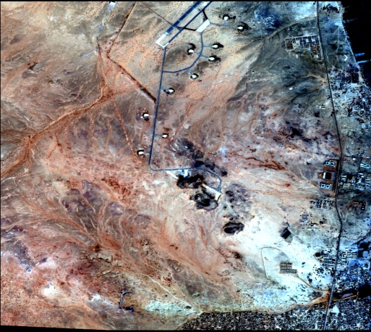 | 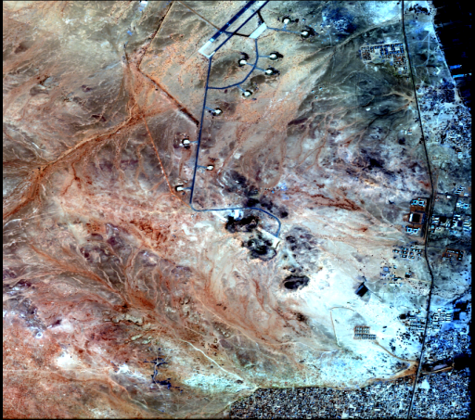
(a) Left Image | (b) Right Image
Figure (3): IKONOS HRS 1M stereo-pair of the study area.

Stereo IKONOS satellite images, with 1m resolution, covering the study area were acquired. These data are delivered in Geo-Tiff format with text files containing the Rational Polynomial Coefficients (RPC) for each image. These RPCs are important for rectifying IKONOS satellite images using Rational Function Model instead of the rigorous models that require the ephemeris data of the satellite orbit. Table (1) shows the main parameters of the available IKONOS HRS 1m stereo-pair.

Table (1): Main parameters of the available IKONOS HRS 1M stereo-pair.
Acquisition Date/Time | 08:41 GMT 27-12-2003 and 08:42 GMT 27-12-2003
Sun Angle Azimuth | 156.1241 and156.3809 degrees
Sun Angle Elevation | 63.50707 and 47.50945 degrees
Overlap | 99%
Rows | 5893 and 6004 pixels
Columns | 5351 and 5357 pixels
Pixel Size X | 1.000 meters
Pixel Size Y | 1.000 meters
Percent Component Cloud Cover | 0
Size (km) | 5.808 km * 5.344 km
- Research Methodology

The framework model of the methodology used in generating the DEM from stereo pair satellite images is shown in Figure (4).
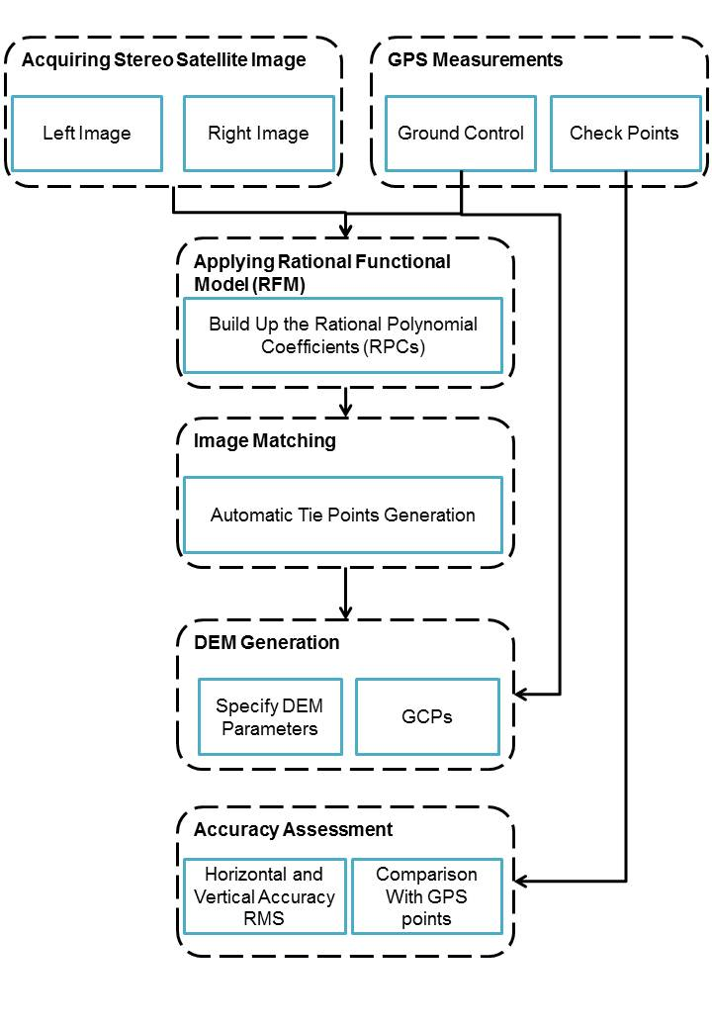
Figure (4): Methodology used for DEM extraction.

Acquiring Stereo IKONOS Satellite Imagery

Initially, selecting the stereo-pair images is a fundamental step for both matching the coverage area and the accuracy. The key selection criteria of the stereo-pair images are:

- Base Height Ratio (B/H): The B/H ratio between the observation base B (distance between the two satellite positions) and the height H (satellite elevation).
- Time Lag: it is important that the time lag between the two images to be as short as possible to avoid any excessive radiometric differences that reduce the accuracy.
- Degree of Overlap: Normally, the common part between the two stereo-pairs depends particularly on the difference in orientation of the two images and always evaluated by the geographic coordinates of the two scenes.
- The ground sample distance should be chosen according to the original map scale in order to preserve the planimetric accuracy of the map (0.2mmat the map scale) [18].
Pixel size =0.2mm*Map Scale (5)

Building the Rational Polynomial Coefficients (RPCs)

The generation of a DEM from stereo-pair images requires rational polynomial coefficients (RPCs) positioning from the satellite sensor. These RPCs would be used to generate the tie points and calculate the stereo-pair images relationship. The IKONOS sensor model supports IKONOS imagery and its associated rational polynomial coefficient (RPC) and metadata files. The metadata files contain information regarding the images in the data set. RPC files contain the necessary information to determine interior and exterior orientation.

Defining the Ground Control Points

Collection of ground control and check points are needed. One of the fastest and accurate systems is the Global Positioning System (GPS). Before selecting the point locations on the ground, the best well-identified points on the images were selected such that they are well distributed all over the common area of the stereo images. These locations are easily identifiable; mostly corners of buildings, and some road intersections.

Static relative GPS positioning technique was used for measuring the ground control points. Two well identified points of the High Accuracy Reference Network provided by the Sudanese Survey Authority, near the study area, were chosen as reference stations. Ten out of twenty two points were selected to be ground control points and the other twelve points were used as check points. Figure 5 shows the distribution of control and check points. Geo-referencing and stereo-model setup of the images was established using different numbers and different distribution of GCPs (three, four, six, eight and ten ground control points).The 10 pyramid points represent the Ground Control Points, while the rest of the points (rounded points are used as check points).
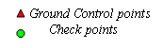
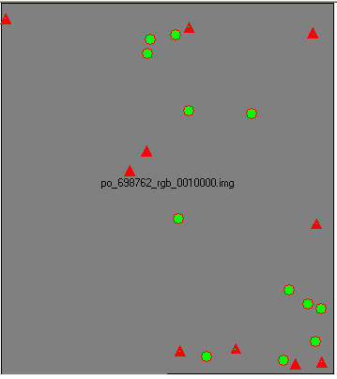
Figure (5): Ground control points and check points of the IKONOS HRS stereo-pair.

Defining the Tie Points

The corresponding image positions of tie points appearing on the overlap areas of the stereo images is identified and measured. Ground coordinates for tie points are computed during block triangulation. Tie points can be measured either manually or automatically. Automatic Tie Point option of Leica Photogrammetry Suite (LPS) was used in this research, where 60 tie points were selected in the overlap area of the IKONOS stereo-pair as shown in Figure (6).
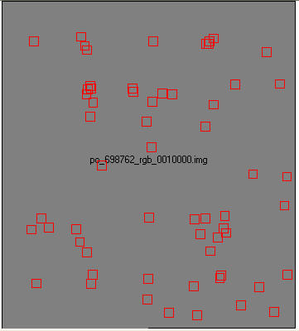

Figure (6): Tie points of the IKONOS HRS stereo-pair.

DEM parameters

In order to generate the best DEM using LPS, DEM parameters, Shown in table (2), was employed:

Table (2): The basic parameters of the output DEM
Output projection | Universal Transverse Mercator Zone 36 North
Datum | WGS84
Units | Meters
Cell size | [3 x 3] meters
Search Size | 17 x 3 pixels
Correlation Size | 7 x7 pixels
Correlation Coefficient Limit | 0.800, the minimal correlation coefficient for a match to be accepted as a correct match. The value can be from 0.10 to 0.99
Topographic Type | Rolling Hills
DTM Filtering | Moderate

The Output DEM

The DEMs was generated from IKONOS stereo imagery using LPS. Once the parameters of the output DEM are set up, the final step of extracting the DEM is conducted. Finally, different DTMs can be constructed depending on the specified DTM output type “American Standard Code for Information Interchange (ASCII) files; Terra Model; Triangulated Irregular Networks (TIN); raster DEMs Environmental System Research Institute (ESRI) 3D Shape files”. Herein, the final rectified DEM is shown in Figure (7).

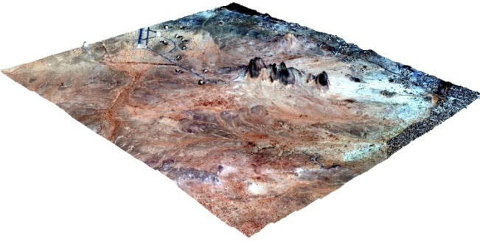 | 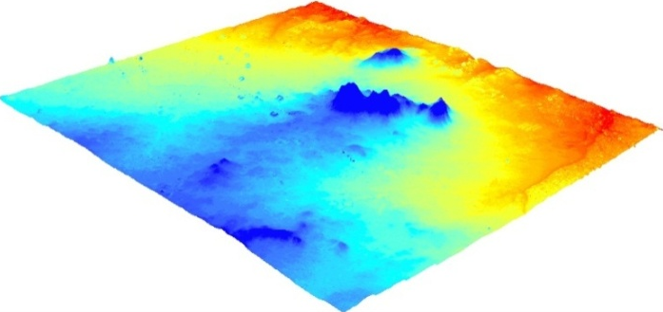
Figure (7): Output of DEM produced from Stereo-HRS data.

It is important to examine the resulted DEM against other data sources to ensure the accuracy and harmony of the simulation model. The following 3D reference sources can be used to calculate DTM accuracy:

- Check points contained within a block file.
- Ground control points contained within a block file.
- Tie points whose XYZ coordinates have been computed “contained within a block file”.
- External raster DEM.
- User-defined 3D coordinates contained within an ASCII file.

On the other hand, Real Time Kinematic “RTK” GPS can deliver almost instantaneous point coordinates with centimeter-level accuracy. There are many applications that can take advantage of RTK technology, including topographic surveying, engineering construction, geodetic control, vehicle guidance and automation, etc.

In our case, Leica dual frequency GPS receivers were placed on a pole and a 100m recording interval was selected. A reference receiver was placed near the test field. In all observing sessions the GDOP (Geometric dilution of precision) value varied between 3 to 6 and the SNR (signal-to-noise ratio) values for almost all satellites were at their maximum. Finally reduction and analysis of GPS measurements were carried out using the Leica Geo-Office software.

- Results and analyses

Several experiments have been accomplished in order to apply the above procedures, the assessment of the accuracy of the produced stereo image and generated DEM have been applied as described in the next sections.

Evaluation of Horizontal and Vertical Spatial Accuracy of the Mathematical Model

In order to assess the model applied for generating the DEM, the performance of the model is discussed in relation to the numbers of ground control points; under conditions of well-defined and well distributed ground control points. Five experiments have been performed using different number of Ground Control Points “GCPs”. The horizontal accuracy and vertical accuracy are evaluated through 12 Check Points “CP”. The number of GCPs per each experiment defined at table (3) and presented at figure (8 a, b, c, d, e)

Table (3): Number of GCP for each case.
Experiment | No. of (GCP)
Case one | 3
Case two | 4
Case three | 6
Case four | 8
Case five | 10

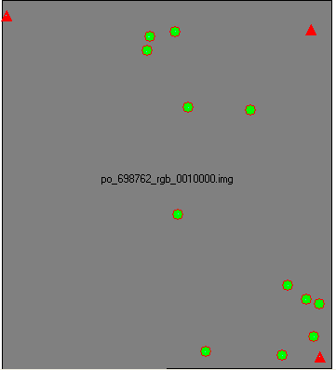 | 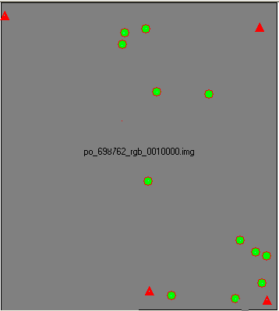 | 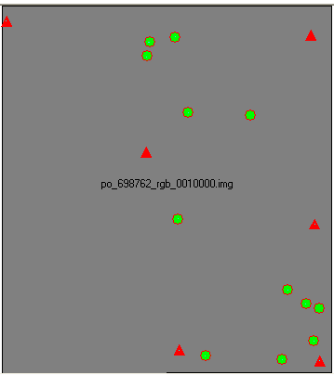
- Case one “3 GCP” | - Case two “4 GCP” | (c) Case three “6 GCP”
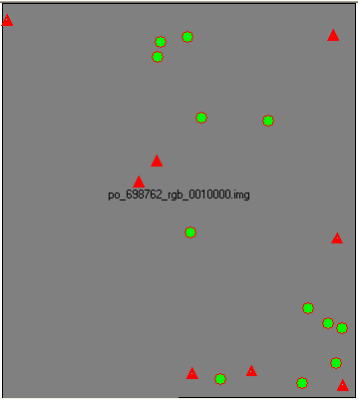 | 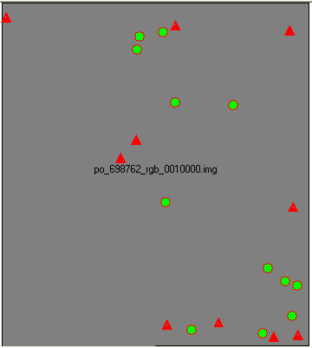
(d) Case four “8 GCP” | (e) Case five “10 GCP”

Figure (8): Different numbers and distributions of GCPs for Stereo-model setup.

The X and Y-residuals and the height (vertical) shift for the GCPs and the 12 CP for the above mentioned cases are analyzed in the following paragraphs.
In case one, the absolute shift in east direction ranges from 0.01m to 1.27m. The absolute shift in north direction ranges from 0.02m to 1.21m. The horizontal resultant ranges from 0.02m to 1.33m. On the other hand, height shifts range from 0.18m to 2.19m.

In case two, there were no significant changes, whereas the absolute shift in east direction ranges from 0.01m to 1.31m. On the other hand the absolute shift in north direction ranges from 0.004m to 1.23m. Consequently, the total horizontal shift ranges from 0.05m to 1.34m. In case of height shifts, the values range from 0.002m to 2.19m.

Incase three, the same trend for the horizontal residuals in east and north direction was recorded. However a little enhancement was observed for the vertical residuals. The absolute shift in east direction ranges from 0.00m to 1.40m and the shift in north direction range from 0.05m to 1.04m. Accordingly, the horizontal resultant ranges from 0.23 m to 1.40m. The height shift ranges from 0.27m to 2.05m.

A significant improvement was recorded in case four. The absolute shift in east direction ranges from 0.03m to 1.23m while the absolute shift in north direction ranges from 0.00m to 1.13m that yields the horizontal resultant values to be from 0.10m to 1.28m. Similarly, 40% enhancement for height shift was observed where the values range from 0.00m to 1.81m.

In case five, the absolute shift in east direction range from 0.07m to 1.14m and the shift in north direction range from 0.01m to 1.08m. Hence, the horizontal resultant ranges from 0.19m to 1.32m. As well, height shifts for case five range from 0.04m to 1.17m.

Meanwhile, the following calculations were prepared to determine the RMS error in easting, northing directions and height respectively.

$RMSeE=\sqrt{\frac{1 }{n}}\sum_{i=1}^{n}{∆Ei^{2}}$ (6)

$RMSeN=\sqrt{\frac{1}{n}}\sum_{i=1}^{n}{∆Ni^{2}}$ (7)

$RMSeZ=\sqrt{\frac{1}{n}}\sum_{i=1}^{n}{∆Zi^{2}}$ (8)

RMSeE = | Root Mean Square error in E direction
RMSeN = | Root Mean Square error in N direction
RMSeZ = | Root Mean Square error in Z
ΔΕі= | the X Residual for GCP і
ΔΝі= | the Y Residual for GCP і
ΔZі= | the Z Residual for GCP і
і = | GCP Number
n = | the number of GCP

The results indicate that the performance of the RFM for DEM generation should be tested in order to reach the best accuracy. The root mean square errors (RMS) of the differences, between estimated and observed values at the study site, are presented in Table(4). The RMS values ranged between 0.81 and 1.05m in the height.

Case one, 3 Ground control points, yielded the worst estimations for topography with RMSE of 1.05m. Case two, 4 ground control points, has the same result as in case one with RMSE of 1.05m. Case three, 6 ground control points, yielded slightly better estimations for topography with RMSE of 0.97m. Case four, 8 ground control points, yielded better estimations for topography than case three with RMSE of 0.84m. Once again, case five, 10 ground control points, increases the accuracy only slightly with RMSE of 0.81m.

Table (4): The RMS of the differences between estimated and observed values for GCP and CP in meter.

Number of GCP | Ground Control Points |  |  | Check Points
 | RMSeE | RMSeN | RMSeZ | RMSeE | RMSeN | RMSeZ
3 | 0.46 | 0.39 | 0.41 | 0.61 | 0.68 | 1.05
4 | 0.40 | 0.43 | 0.36 | 0.62 | 0.68 | 1.05
6 | 0.47 | 0.55 | 0.35 | 0.67 | 0.67 | 0.97
8 | 0.55 | 0.52 | 0.70 | 0.59 | 0.67 | 0.84
10 | 0.55 | 0.48 | 0.69 | 0.58 | 0.67 | 0.81
In this study 10 GCPs were used and about 60 tie points were generated automatically, and the RPC model was corrected by the 3rdorder polynomials. The results indicate that, the RMS of horizontal and vertical residuals at the GCPs and check points were within one pixel. Thus the DEM from IKONOS stereo imagery is accurate enough for the accuracy of the 1:10,000 contour maps. In general, the RMSE value should be within two times of the original pixel size of the imagery for the output DTM to be considered accurate to real-world conditions.

Evaluation of the Produced DEM

The resulted DEM was then evaluated through the integration of a highly accurate RTK topographic survey data for about 600 points, which was conducted for the study area. The detailed analyses of the DTM performed through the comparison with the GPS measured points. Results are shown in table (5) and figure (9).

The proposed method exhibited few prediction errors over 2m. Surprisingly, a relatively large data scattering (82.5%) is found to be between 0m and ±1m indicating the low differences between estimations and observations and hence the accurate performance of the method. One question still remains, why most of the estimated heights are lower than the corresponding observed heights. One possible reason for that can be the method of image acquisition in case of IKONOS stereo pair, an image collected at a low elevation angle (above 60 degrees) as well as an image collected at a higher elevation angle (above 72 degrees) with 30°- 45° convergence (0.54 to 0.83 base-to-height ratio) as previously mentioned.

Table (5): Statistics of height differences between DTM and GPS data.
Residuals  (Height Difference) | Frequency | Percentage % | Residuals  (Height Difference) | Frequency | Percentage %
0.00 :-0.25 | 96 | 16.4% | - :0.25 | 79 | 13.5%
-0.25:-0.5 | 108 | 18.4% | 0.25:0.50 | 43 | 7.3%
-0.50 :-0.75 | 85 | 14.5% | 0.50 :0.75 | 37 | 6.3%
-0.75:-1.00 | 39 | 6.6% | 0.75:1.00 | 12 | 2.0%
-1.00 :-1.25 | 32 | 5.5% | 1.00 : 1.25 | 6 | 1.0%
-1.25:-1.50 | 19 | 3.2% | 1.25:1.50 | 5 | 0.9%
-1.50 :-1.75 | 7 | 1.2% | 1.50 :1.75 | 5 | 0.9%
-1.75:-2.00 | 3 | 0.5% | 1.75:2.00 | 0 | 0.0%
-2.00:-2.25 | 3 | 0.5% | 2.00:2.25 | 3 | 0.5%
-2.25:-2.50 | 4 | 0.7% | 2.25: 2.50 | 79 | 13.5%
-2.50 :-2.75 | 1 | 0.2% | 2.50 : 2.75 | 1 | 0.2%

Frequency of Occurrence

Z - Residuals
Mean value
Figure (9): Frequency of occurrence versus Z-residuals.

CONCLUSIONS

In this research, an attempt is made to develop a workflow for DEM production using IKONOS HRS stereo-pair. The workflow comprises all necessary technical steps dealing with satellite imagery until extracting desired information. An experimental test for the generated DTM is also made. The test results show that 83% of the points are within ±1m. The automated DTM extraction process has some difficulties in urban areas specifically around buildings, bridges, trees, and other extruding features on the earth’s surface. The accuracy of the sensor model, the accuracy of the image matching, and the software used are the principal factors affecting the DEM accuracy. The research compared the heights at each point where the horizontal coordinates of two DEMs are the same. The average vertical difference (absolute values) of 605 points was 0.65m while the Root Mean Square Error (RMSE) was 1.01m. Thus the produced DEM from IKONOS stereo imagery is accurate enough to meet the accuracy of the 1:10,000 contour maps.

Further Work

The extracted elevation data from high resolution stereo-optical satellite imagery can be used with different mathematical models to refine and improve the solution. The extracted DEM can be used for accuracy assessment of Ortho-rectification of high resolution satellite image.

References

[1] GarAlnabi, I., Elshami, M. and Awadelgeed, M., (2011a): "Quality Assessment of DEMs Derived from 1:100,000 Scale Topographic Maps". UofKEJ Vol. 1 Issue 1 pp. 32-40 (June 2011). Available online at ejournals.uofk.edu.
[2] GarAlnabi, I., Elshami and Awadelgeed, M., (2011b): "Accuracy Assessment of SRTM Elevation Data". Sudan Engineering Society Journal, March 2011, Volume 57; No.l.
[3] Iida, Y., Matsuo, K. and Sato, J. (2001): "A Study of Making1:25,000 Topographic Maps by Using High-resolution Satellite imagery". Proceedings of Regular Conference of Japan Cartographers Association.
[4] Fraser, C.S., Hanley, H.B. and Yamakawa, T. (2002): "Three-dimensional Positioning Accuracy of Ikonos Imagery". The Photogrammetric Record, Vol.17, No.99, 465-479.
[5] Chen, L. C. and Lee, L. H., (1993): "Rigorous Generation of Digital Orthophotos from SPOT Images". Photogrammetric Engineering and Remote Sensing, 59(3):655–661.
[6] American Society for Photogrammetry and Remote Sensing, 2001. Digital Elevation Model Technologies and Applications: The DEM Users Manual. ASPRS, Bethesda, MD.539 p.
[7] Lerome, K., and Etienne, B. C., Marc, A., Frederique, C. and Eric, T., (2009): "SPIRIT SPOT5 Stereoscopic Survey of Polar Ice: Reference Images and Topographies during the Fourth International Polar rear (2007_2009)". ISPRS Journal of Photogrammetry and Remote Sensing .Vol. l-I.pp 20-i_212.
[8] Toutin. T., (2001): "DEM Creation from New VIR Sensors: IKONOS, ASTER and Lansat-7". In proceedings, IEEE-IGARSS, Sydney, Australia.
[9] Zhen, X., Huang, X. and woh, L., K., (2001): "Extracting DEM from SPOT Stereo Images", 20 Asian Conference on Remote Sensing, Singaphore.
[10] Wang, X., Fu, X., Xu M., (2008): "Effect of Incidence Angle and Accuracy of DEM on Quality of SPOTS Ortho-image Map", Chineese Journal. 2008 (SI), pp 134-137.
[11] Poli, D., Zhang, L. and Gruen. A., (2004): "SPOTS-HRS Stereo Images Orientation and Automated DSM Creation". ISPRS Vol 35, Istanbul.
[12] Satellite Imaging Corporation, (2012): "IKONOS Stereo Satellite Imagery". Available at: http://www.satimagingcorp.com/svc/ikonos-stereo-satellite-images.html. Last accessed at 19 July 2012.
[13] Tao, C., Hu, Y., Mercer, J., Schnick, S. and Zhang, Y., (2000): "Image Rectification Using a Generic Sensor Model- Rational Function Model". The International Archives of Photogrammetry and Remote Sensing, Vol. 33, Part B3, pp. 874-881, Amsterdam, The Netherlands.
[14] Hu, Y., Tao, V. and Croitoru, A., (2004): "Understanding the Rational Function Model: Methods and Applications". The International Archives of Photogrammetry and Remote Sensing, Istanbul, Turkey.
[15] Tao, C. and Hu, Y., (2001): “A Comprehensive Study on the Rational Function Model for Photogrammetric Processing”. PE&RS, 67(12), pp. 1347-1357.
[16] McGlone, C., (1996): "Sensor Modeling in Image Registration". Digital Photogrammetry, an Addendum to the Manual of Photogrammetry, Chapter 5, American Society for Photogrammetry and Remote Sensing.
[17] Elashmawy, N., Elmanadily, Y., and Barakat, M., (2005): “Comparative Analysis and Evaluation of Various Mathematical Models for Stereo IKONOS Satellite Images". FIG Working Week 2005. Available at: https://fig.net/pub/cairo/papers/ts_27/ts27_03_elashmawy_etal.pdf. Last Accessed at 19 July 2012.
[18] Thomas, R., (2002): "Digital Map Updating from Satellite Imagery", IAPRS, Volume XXXIV, Part2, Commission II, Xi’an, Aug.20-23, 2002.

